Trace FC Data Curation

Quick version: 1) Copy over all relevant files to the F: drive, 2) then back up immediately to google drive using rclone.

Directory Structure: F:\Nat\Trace_FC\Rat_name\YYYY_MM_DD_dayname (dayname = habituation, training, recall, or LTMrecall). See below:

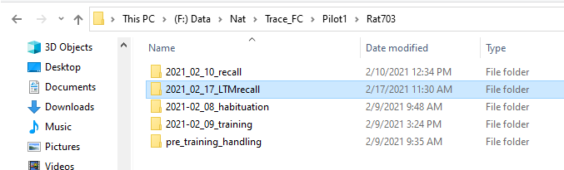

Files to copy over: .tak files (Motive), .mp4 files (Camera app for webcam), .csv files (timestamps from python), .wave files in the correct folders (AVISoft).

FILE LOCAITONS

CSV FILES ARE LOCATED IN: c:\Users\nkinsky.

Camera files are located in the “Pictures” folder. All other files are located in the folders specified by you.

Files to create:

.avi files from Motive .tak files. Go to View->Data Pane and select each Take in the list on the left of the screen. Then either right click or go to File->Export Video and save the video.

End product should look like the below:

